BATTERIES (2AA) POWERED SMART SHOWER TIMER

Input ½ inch port from the shower pipe

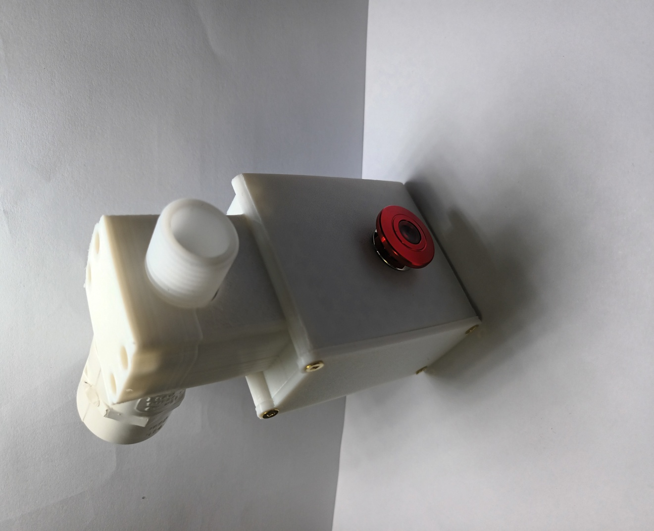

START/STOP button   
(press twice after the module goes to sleep) and neglected its operation for 5 seconds after second user was selected

Built in BUZZER will signal the beginning and the end of the soak, soap, rinse intervals. Also there is a buzzer notification after one minute from the start of the shower (hot water available) and before last minute in soak and rinse intervals.  
Before the start of the shower the buzzer runs for 5 seconds giving a warning about HOT WATER and if during this period of time START/STOP is pressed the second user routine is selected

LED status light   
(flashing when timer is running, solid when second user selection confirmed and at the end of the shower before timer goes to sleep

Batteries compartment

Output ½ inch port to the shower head